Remarks Delivered at Earthjustice All Staff Meeting

We’ve got more inspiring stories coming up next. But before that, I want to spend a few minutes with a forward look at the victories we have yet to build and the role each of you have to play.
If you spend any time talking with our team over the next few days you are going to notice a trend: we are going to ask you to get personal.
There’s a reason for that: A majority of Americans believe that climate change is a problem.
Essentially all of the folks whose faces we can clearly see in this staff photo if we pretended this was the entire country’s population
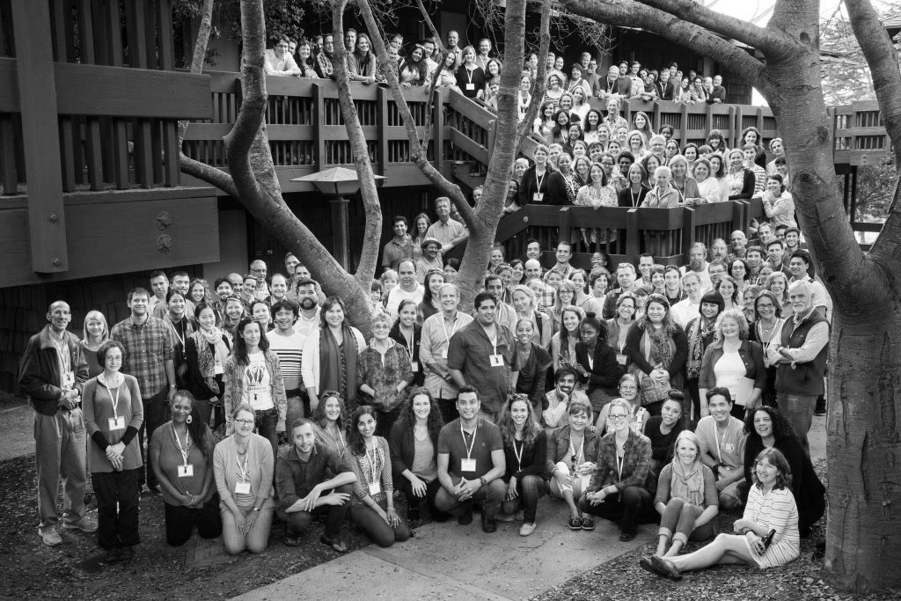
But only a small percentage of those people – 13 percent – are truly alarmed about it. Basically all of the people in the photo who are sitting or kneeling on the ground. And of that fraction of a fraction, just one in four have taken action on the issue in the past year.
So what our team is focusing on is reaching the people in the second, third, fourth, fifth rows. We need more of the people who believe climate change is a problem to prioritize it, and to act on it. To do that, we need to bring this big complex issue – the problems and the solutions – way down to the human scale.
Why is this? The human brain has evolved to help us respond to short-term threats, so we need to make real and immediate the threat posed by climate change, while not overwhelming people and freezing them into inaction.
It’s a delicate balance – but we think one way to do it is to bring people in with stories – of the people on the frontlines of the fight against fossil fuels and for 100 percent clean energy. That’s you. That’s the folks you work with.
The cat’s apparently out of the bag: In a recent article by the LA Times, they blew the lid open on our secret plan: “Earthjustice, known for years for filing lawsuits, has asked staff to post personal stories about what inspires their work.”
So what does that look like?
It’s the story of West Virginians who are banding together deep in the heart of coal country, refusing to bail out First Energy’s Wall Street shareholders, and with the help of our coal team and clean energy team they are calling on their leaders to invest in solar and energy efficiency.
It’s the Marylanders who, now that our policy and legislation team helped get a community solar bill passed are going to be turning out to community meetings around the state to learn how they can grow their own community solar gardens and break free of the fossil fuels that are poisoning their neighbors in communities like Brandywine, the majority Black community in Prince George’s county whose residents are facing the prospect of living within close proximity of six power plants -- 30 percent of the state’s entire fleet.
It’s helping a supporter or activist understand why our energy system is the way it is. Who it benefits. Who it hurts. And what they can do to change it.
My challenge to each of you here is identify the people who are being impacted by your work or the work you want to do. Talk to them, get to know them, build trust and see if they are willing to share their story.
The result could be more powerful than any of us could imagine.
By now you have all heard the story of The Standing Rock Sioux Tribe that has taken a stand against the Dakota Access oil pipeline, inspiring tribes from around the country and world to visit the Sacred Stones camp and to express support. We are witnessing history in the making.
The story you may not have heard is how the Standing Rock Sioux Tribe cold-called our office and asked for legal help after hearing the story of how we worked with the Salish Sea tribes in their fight against the TransMountain oil pipeline - a beautiful story captured in a photo essay by our resident multi-media producer.
Our team in Seattle valiantly answered the Standing Rock Sioux Tribe’s call for support — I hope you’ll take time out during the next few days to speak with that team and hear the incredible behind-the-scenes story about their work with the Tribe.
Win or lose, these are the stories that grab people’s heart and make it impossible for them not to act on the great existential threat posed by fossil fuels. So go forth and help us find and tell the stories that let communities know that there’s an organization out there who will fight for them. And, who knows, that fight may just end up inspiring an entire generation of leaders.
Before we take questions, some of you may have noticed that I haven’t actually offered up a story of my own. And when we were preparing beforehand, my fellow presenters gently suggested that if I want you all to take this storytelling seriously, I should lead by example.
Here is a story that I’ve kept with me for the past 20 years and that I’ve often turned to for inspiration.
When I was in high school, I was lucky enough to participate in something called the New York Watershed Youth Summit, where kids from the Bronx, Brooklyn, Queens, Manhattan and Staten Island gathered with kids from the Catskills for a weekend in the woods to learn about the ways our lives were bound together by the system of upstate reservoirs that supply drinking water to the 8 million residents of New York City.
One night the musicians Jay Ungar and Molly Mason came to the lodge and played us a song and told us a story.
The song was called Ashokan Farewell
[Double click icon to play song)

(Ashokan Farewell by Jay Ungar. Used by permission. All rights reserved.)
It's named for the largest reservoir in the New York City drinking watershed.
But before Ashokan was a reservoir, it was a community. In the early 1900s it was dammed and flooded.
When there’s a drought, you can still see the foundations of the homes that were destroyed.
But, as the legend goes, there was at least one structure that wasn’t destroyed in the flood.
On the night before the waters would flood their community, the townspeople gathered and hoisted the church from its foundation, carried it to higher ground.
That story has always stayed with me, from the time I was an idealistic 16-year old girl until this moment as I stand before you, an only slightly less idealistic 36-year old woman.
Now, I don’t know if the story is true and I don’t really want to know. Because, I believe now as I believed then, that the essence is true.
That there are sacred things in this world. They are worth protecting. When the flood waters rise, we come together and we struggle and we carry these sacred things to higher ground.
Climate change is happening.
The water is rising.
But here we all are, and across the country and world we have our extended family of climate movement partners and activists.
We’ve come together to keep fossil fuels in the ground and plant the seeds for a thousand solar gardens.
We’re struggling and we are determined. I’m proud to be here with you all, shoulder to the wheel, doing the work to slow the rising waters and keep everything we love on safe ground.

